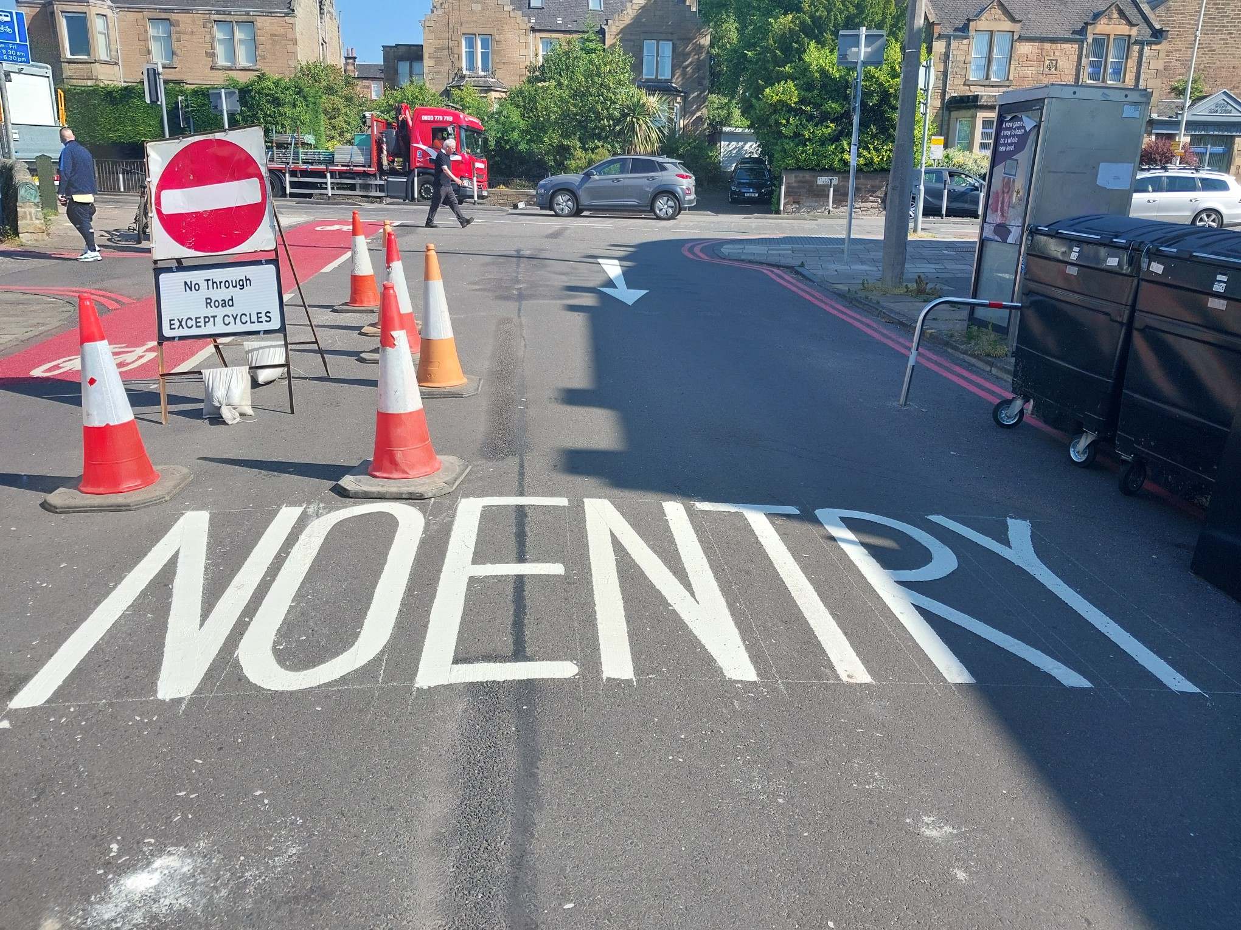
Corstorphine Community Council Novemeber 23
compiled by PC Sam Davison

Welcome to our newsletter for November 23
Lo
Local area crime Statistics
Statistics researched locally by PC Davison (figures do not include the Gyle area)
Period covers: 24th Oct- 21st Nov
Calls for service
2022 period– 243 2023 period - 231 (increase is due to one source of repeated calls)
Crimes 2022 period 51 – 2023 period – 47
Notable Crimes
Housebreakings
5th November – Broomhall gardens/Road
8th November Corstorphine Hill Gardens.
Other
24th October – Ladywell Road – Car window smashed
2nd November Broomside terrace, Smash van window stealing from within
17th November Serious Assault Carrick knowe – Saughton. 10 youths attacked another with a weapon, enquires by the Violence reduction Unit at Corstorphine Police station

*

Local issues we have been tackling:
OFFICER COMMENTS; PC Davison

Local Policing Structure.
Chief Inspector Neil Wilson
Inspector Carolyn Flynn
Sergeant Sandra Watt
Community officers PC Sam Davison & PC Susan Fulton.

Youth Issues.
Youths causing anti-social behaviour are being reported around the Corstorphine Retail park and the Gyle. Free public transport has seen youths come from outwit the area. But we are not seeing the same scale of issue as other parts of the city.
Recently there has been reports of youths making bonfire at Pinkhill path.

Bonfire night – Operation Crackle.
Very few calls relating fireworks in the Corstorphine area.

Corstorphine Connections – Investigations into the vandalism to the bus gate camera remain open and anyone with information is encouraged to contact us.
Monitoring and enforcement of the No entry Featherhall Avenue continues. People are passing the no entry then turning left passed the Centurion are risking receiving 3 points and £100 fine.

Advice section
The Little Book of Big Scams – 5th Edition (sbrcentre.co.uk).
Please take reasonable precautions when leaving your property for an extended period of time. advice here. Your house - Police Scotland

Trusted traders
Research companies offering to carry out work for you. Don’t get work done by someone who is just passing by or ‘cold calling’ you. Use the Trusted Trader Scheme https://trustedtrader.scot/Edinburgh/ 0131 513 9921
Please feedback any questions to myself via my e-mail.
Kind Regards,
Sam
PC Davison
Sam.davison@scotland.pnn.police.uk or tel 101.
EdinburghCPTNorthWest@scotland.pnn.police.uk
About Us
101
for non emergencies
EdinburghCPTnorthwest@Scotland
.pnn.police.uk
@
EdinPolNW
Edinburgh Police Division
www.scotland.police.uk
Local Area Commander:
Chief Inspector Neil Wilson
Corstorphine Community Policing Team
based at Corstorphine Police team

Your local Community Beat Officers

PC Sam Davison
PC Susan Fulton
Contact Us:

