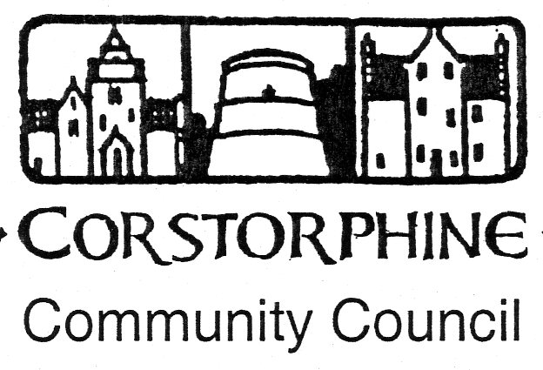

Secretary: K.Swinney, 100, Saughton Road North, Edinburgh, EH12 7JN.
Telephone 0131 334 3461 14th September 2016.

The next meeting of the Corstorphine Community Council will be held on Wednesday 21st September 2016 in the Heritage Centre, Dower House, St. Margaret’s Park, Corstorphine at 7.30pm prompt.
This being the last meeting of the current Community Council before the election for the new three year period Community Council appointment a good attendance is hoped for.

AGENDA.

- Apologies for absence.
- Police report.
- Councillors reports and questions.
- Youth report.
- Minutes of meeting 17th August 2016.
- Treasurer’s report.
- Sub Committee Reports. ( Amenities / Planning / Traffic).
- Community Council 3 year elections. ( All applications in by 26th September).
- Corstorphine Placemaking Exercise.
- Correspondence.
- Any other competent business.

