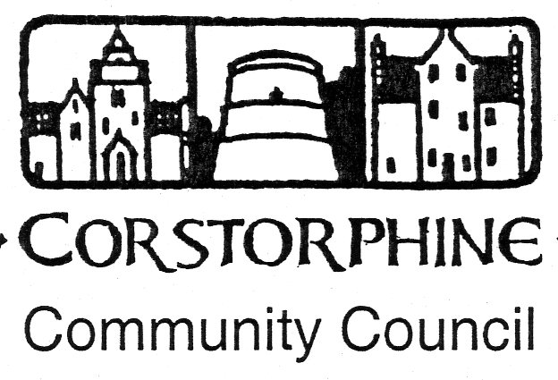

Secretary: K. Swinney, 100 Saughton Road North, Edinburgh EH12 7JN
Telephone 0131 334 3461. 10th May 2016.

The next meeting of the Corstorphine Community Council will be held on Wednesday 18th May 2016 in the Heritage Centre, Dower House, St. Margaret’s Park, Corstorphine at 7.30pn prompt.
It is hoped you will be able to attend.

AGENDA.

- Apologies for absence.
- Police report.
- Councillors reports and questions.
- Youth report.
- Minutes of meeting 20th April 2016.
- Treasurer’s report.
Annual Accounts 1st April 2015 to 31st March 2016.
- Sub Committee Reports. ( Amenities / Planning / Traffic ).
- Corstorphine Fair 4th June 2016.
- Spring Consultations.
- Area Walkabout Success and Report.
- E.A.C.C. meeting report 28th April. ( W. Hope)
- West Edinburgh NP Environment Sub Group meeting report 12th May 2016.
- West Community Safety Forum Meeting report 21st April 2016.
- Corstorphine Web-Site.
- Correspondence.
- Any other competent business.

