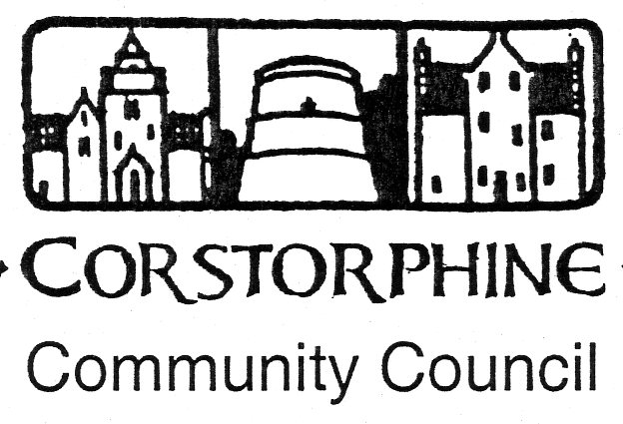

Secretary: K. Swinney, 100 Saughton Road North, Edinburgh EH12 7JN
Telephone 0131 334 3461. 11th January 2016

The next meeting of the Corstorphine Community Council will be held on Wednesday 20th January 2016 in the Heritage Centre, Dower House, St. Margaret’s Park, Corstorphine at 7.30pm prompt.

A presentation is due to be given by GVA James Barr on Phase 2 International Business Gateway, a large development of serious concerns for West Edinburgh involving traffic.

It is hoped for a full attendance this being the first meeting of the New Year.

AGENDA

- Apologies for absence.

- Police report.

- Guest Speakers. GVA James Barr (Awaiting Confirmation)

- Councillors reports and questions.

- Youth report.

- Minutes of meeting 9th December 2015.

- Treasurer’s report.

- Sub Committee reports. (Amenities / Planning / Traffic).

- Children and Families New 3Year Grant Programme starts 1st April 2016.

- Corstorphine Web-Site.

- Correspondence.

- Any other competent business.

