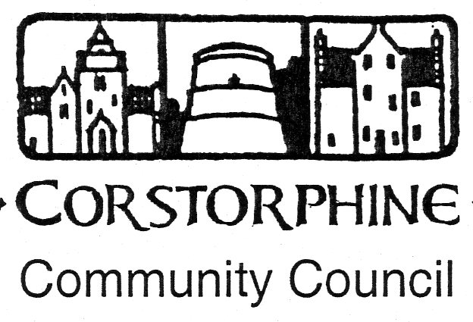

Secretary: K. Swinney, 100 Saughton Road North, Edinburgh EH12 7JN
Telephone 0131 334 3461. 9th February 2016.

The next meeting of the Corstorphine Community Council will be held on Wednesday 17th February 2016 in the Heritage Centre, Dower House, St. Margaret’s Park , Corstorphine at 7.30pm prompt.
A full attendance is hoped for.
AGENDA.

- Apologies for absence.

- Police report.

- Councillors reports and questions.

- Youth report.

- Minutes of meeting 20th January 2016.

- Treasurer’s report.

- Sub Committee reports. (Amenities /Planning /Traffic.)

- Area walkabouts.

- Spring Consultations.

- West Edin. Environment Sub. meeting 28th Jan. report.

- Corstorphine Web-Site.

- Correspondence.

- Any other competent business.

