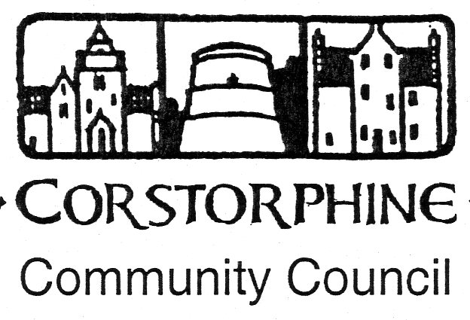

Secretary: K. Swinney, 100 Saughton Road North, Edinburgh EH12 7JN
Telephone 0131 334 3461. 10th August 2016

The next meeting of the Corstorphine Community Council will be held on Wednesday 17th August 2016 in the Heritage Centre, Dower House, St Margaret’s Park, Corstorphine at 7.30pm prompt.
This being our first meeting after our holiday it is hoped for a full attendance.

AGENDA.

- Apologies for absence.
- Police report.
- Councillors reports and questions.
- Youth report
- Minutes of meeting 15th June 2016.
- Treasurer’s report.
- Sub Committee reports. ( Amenities / Planning /Traffic).
- Community Council 3 year elections. ( Encourage new members.)
- Neighbourhood Partnership meeting 23rd August 2016 in Corstorphine Old parish Church Hall, Kirk Loan. Preparation for Official Launch of C.C.C. consultations.
- Community Council plans for future after election results.
- Correspondence
- Any other competent business.

