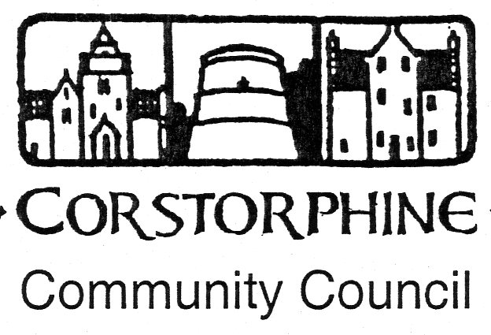

Secretary: K. Swinney, 100 Saughton Road North, Edinburgh EH12 7JN
Telephone 0131 334 3461. 12th April 2016.

The next meeting of the Corstorphine Community Council will be held on Wednesday 20th April 2016. in the Heritage Centre, Dower House, St. Margaret’s Park, Corstorphine at 7.30pm. prompt.
A good attendance is hoped for.

AGENDA.

- Apologies for absence
- Police report.
- Councillors reports.
- Youth report.
- Minutes of meeting 15th March 2016.
- Treasurer’s report.
- Sub Committee reports. ( Amenities / Planning / Traffic.)
- Spring Consultations.
- Corstorphine Fair 4th June 2016.
- West Edinburgh Neighbourhood Partnership meeting report 23rd March 2016.
- Area Walkabouts.
- Scottish Elections Thursday 5th May 2016.
- Corstorphine Web-Site.
- Correspondence.
- Any other competent business.

